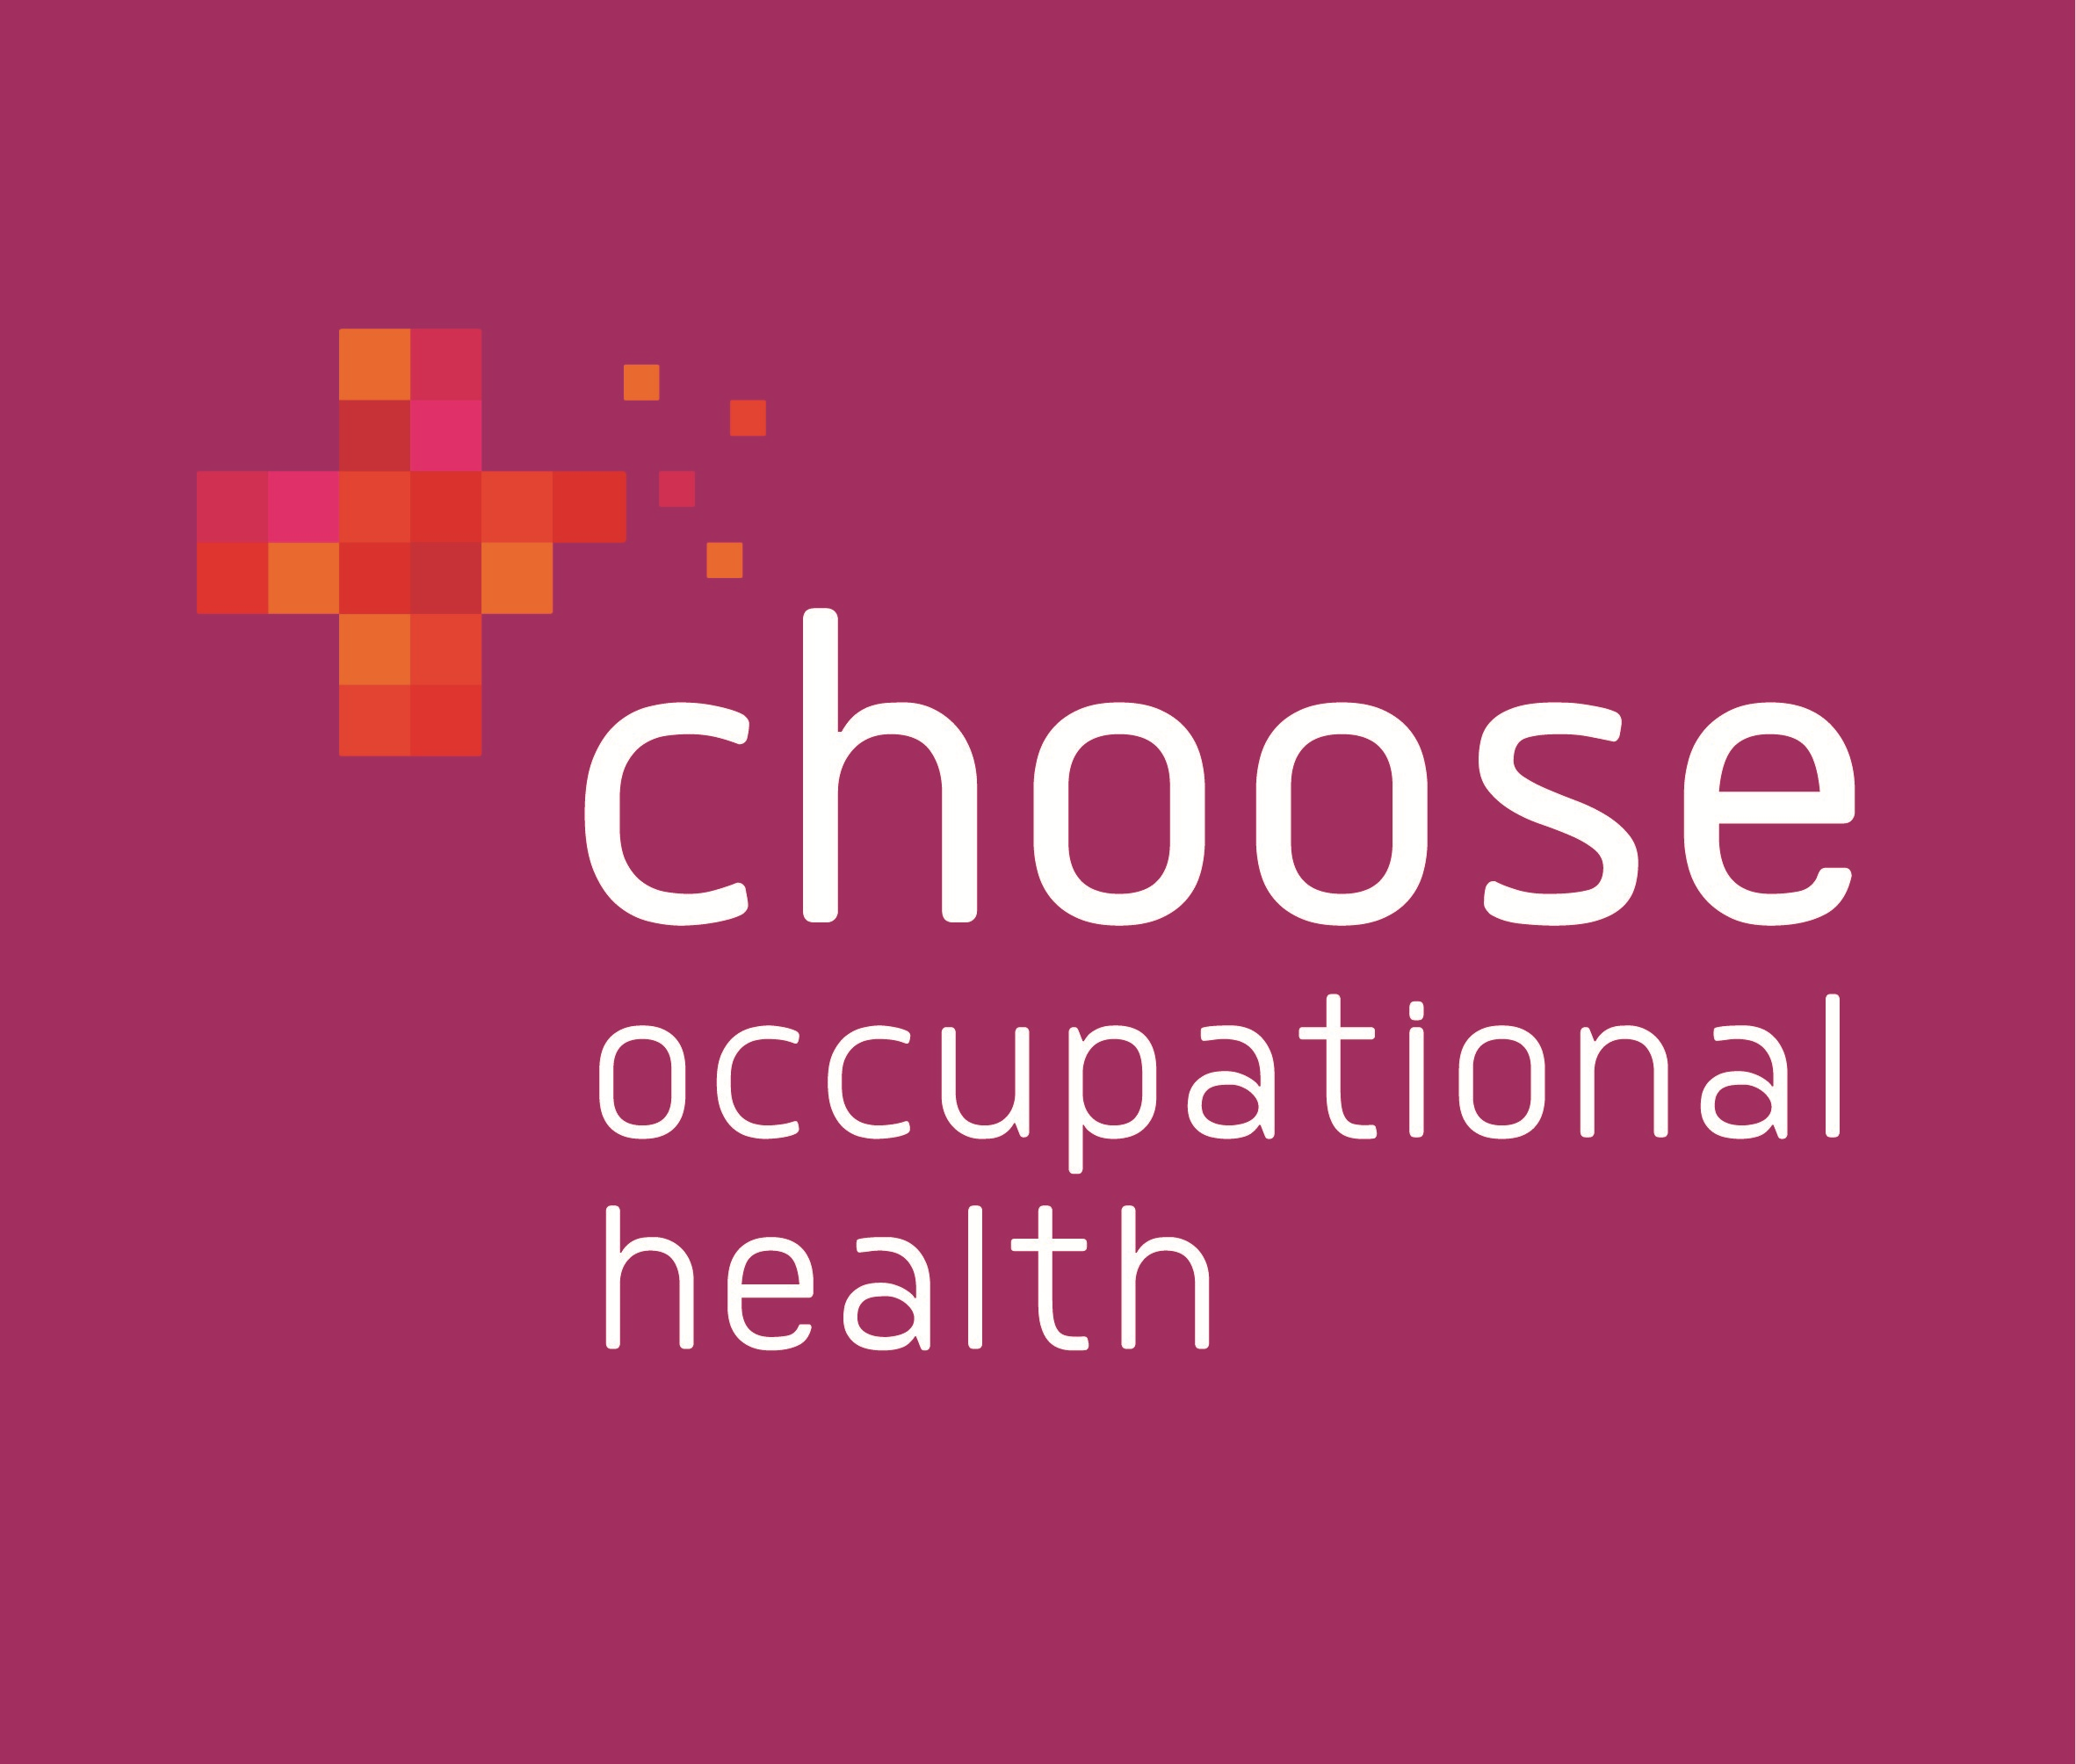
We are looking for a qualified Occupational Health Nurse or a Registered General Nurse, Nurse Practitioner on Part 1 NMC Register who want to take the next step in their career.

This is an exciting opportunity to join a fast-growing Carlisle-based employer, providing high quality occupational health services to businesses across Cumbria. Whether you have previous occupational health experience or you are interested in changing career direction – We’d love to hear from you.

The opportunities we currently have are:

1 x Occupational Health Adviser or Adviser (Development Role)

Qualifications - Occupational Health Diploma or RGN on part one of the NMC register with a minimum of five years post qualification. With a commitment and motivation to complete further professional qualifications and training.

Hours – up to 30 hours per week flexibly worked between
Monday – Friday

Salary – £28,000 (development role) – £37,000 (qualified OH Adviser) depending on experience and qualifications. All salary increases are based on a competency framework and successful completion of a 6 month probation period.

Applicants must have a full UK driving licence and use of a vehicle as there will be a requirement to travel to client premises. Mileage contributions will be paid at the standard HMRC rate. 20 days holiday per year (pro rata for part-time employees) 25 days after 5 years service and a company pension scheme.
Why choose Choose Occupational Health?

Based in Carlisle, we are an award-winning, family run business, committed to helping organisations across Cumbria create a happier and healthier workforce through the provision of high quality Occupational Health services. We offer reliable, independent and tailormade services to businesses and organisations, regardless of sector or size. Working in partnership with our clients we provide clear and trusted advice, as well as access to a range of services that help an organisation support the health and well-being of their staff. With a proven track record, our services enable companies to reduce absence costs, increase staff retention, improve productivity and increase profitability.

We pride ourselves on our ability to build strong relationships with clients and we place high value on excellent customer service and personalised care. Our staff are knowledgeable, approachable and visible. As a member of the Choose family we’ll need you to be engaged and involved.

We have a diverse and friendly team who work across the county in a variety of roles. As well as striving to help our clients create a healthier and happier workforce, we are equally passionate about looking after our own. Our business is built on ethical practice and values and CPD is central to our vision. All staff have access to appropriate workplace training and self-development is encouraged – we want all our people to thrive!

As well as training we are also committed to protecting the health & well-being of our team members and we are incredibly proud of the ‘close-knit’ community that exists within our workforce. Team members support each other professionally and personally and we offer a wide range of social opportunities both in and outside working hours. Regular health & well-being promotions and events are organised both on and off-site and we are incredibly active in the community, supporting local charities through fundraising and volunteer time.

Each member of the Choose Occupational Health ‘family’ brings something special to the organisation. Staff engagement is key to our vision and we communicate regularly with departments through a variety of platforms. We involve staff in decision making, we value everyone’s contribution; everyone has a voice. Our people are integral to our success and therefore integral to our brand. Their stories are our stories and we put them front and centre. The strength of our ‘family values’ were recognised recently at the North West Family Business Awards in 2020 when we were proud to be finalists in the Business and Community category and voted joint winners in the ‘People’s Choice: Cumbria’.

In terms of location, we are based in the heart of Cumbria. Carlisle is a small city but has plenty of amenities and facilities to enjoy, whatever your situation. The area has plenty of great schools, a large hospital and a burgeoning cultural scene as well as a new city airport. With the Lake District on our doorstep, there’s plenty to explore, from the tranquil beauty of the lakes to the thrill seeking challenge of adventure sports. A career with Choose Occupational Health could provide you with the perfect work / life balance.

If you are interested, please complete an application form from our website chooseoccupationalhealth.co.uk/job-vacancies/ and email or post for the attention of:

Cheryl Bryson, Office Manager, Choose Occupational Health, 14 Hartington Place, Carlisle, CA1 1HL

Tel: 01228 513687, Email: office@chooseoh.co.uk

Deadline for applications 18th December 2020

If sufficient response is received this advert could be closed earlier than the specified closing date, please apply as soon as possible to ensure your application is considered.

