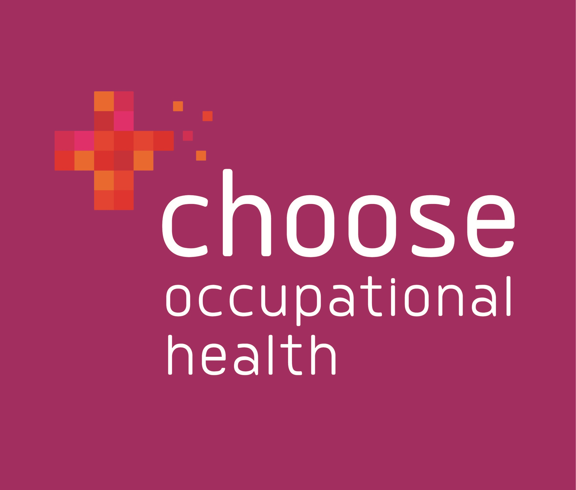
We are looking for an Occupational Health Technician or an Occupational Health Screening Nurse.

This is an exciting opportunity to join a fast-growing Carlisle-based employer, providing high quality occupational health services to businesses across Cumbria. Whether you have previous occupational health experience or you are interested in changing career direction – We’d love to hear from you.

The opportunities we currently have are:

1 x OH Technician or 1 x OH Screening Nurse

Qualifications - OH Technician – Occupational Health Technician (OHT Course) or a Certificate in Surveillance Audiometry. With a commitment and motivation to complete further mandatory training as required. Or experience of working in a health screening role

OH Screening Nurse - RGN or NMC registered with a minimum of five years post qualification. With a commitment and motivation to complete further mandatory training as required.

Hours – up to 15 hours per week flexibly worked between
Monday – Friday

Salary – £19,968 pro rata. All salary increases are based on a competency framework and successful completion of a 6 month probation period.

Applicants must have a full UK driving licence and use of a vehicle as there will be a requirement to travel to client premises across Cumbria. Mileage contributions will be paid at the standard HMRC rate. 20 days holiday per year (pro rata for part-time employees) 25 days after 5 years service and a company pension scheme.
Why choose Choose Occupational Health?

Based in Carlisle, we are an award-winning, family run business, committed to helping organisations across Cumbria create a happier and healthier workforce through the provision of high quality Occupational Health services. We offer reliable, independent and tailormade services to businesses and organisations, regardless of sector or size. Working in partnership with our clients we provide clear and trusted advice, as well as access to a range of services that help an organisation support the health and well-being of their staff. With a proven track record, our services enable companies to reduce absence costs, increase staff retention, improve productivity and increase profitability.

We pride ourselves on our ability to build strong relationships with clients and we place high value on excellent customer service and personalised care. Our staff are knowledgeable, approachable and visible. As a member of the Choose family we’ll need you to be engaged and involved.

We have a diverse and friendly team who work across the county in a variety of roles. As well as striving to help our clients create a healthier and happier workforce, we are equally passionate about looking after our own. Our business is built on ethical practice and values and CPD is central to our vision. All staff have access to appropriate workplace training and self-development is encouraged – we want all our people to thrive!

Role

Providing high quality occupational health screening assessments, including hearing assessments, blood pressure, urine testing in line with approved protocols, best practice recommendations and Choose Occupational Health Quality Standards and escalate cases appropriately. Good organisation, time management and IT skills are essential to autonomously deliver busy clinic schedules and provide outcome paperwork to our clients.

If you are interested, please complete the application form found on our website chooseoccupationalhealth.co.uk/job-vacancies/ and email or post for the attention of:

Cheryl Bryson-Thomson, HR & Operations Manager, Choose Occupational Health, 14 Hartington Place, Carlisle, CA1 1HL

Tel: 01228 513687, Email: office@chooseoh.co.uk

Deadline for applications 31st March 2022

If sufficient response is received this advert could be closed earlier than the specified closing date, please apply as soon as possible to ensure your application is considered.

